Fossils-Burgess shale-like- Aglaspida

# ULTRA RARE ARTHROPOD Leptaglaspis schmidti - ORDOVICIAN AGLASPID with Clonograpt

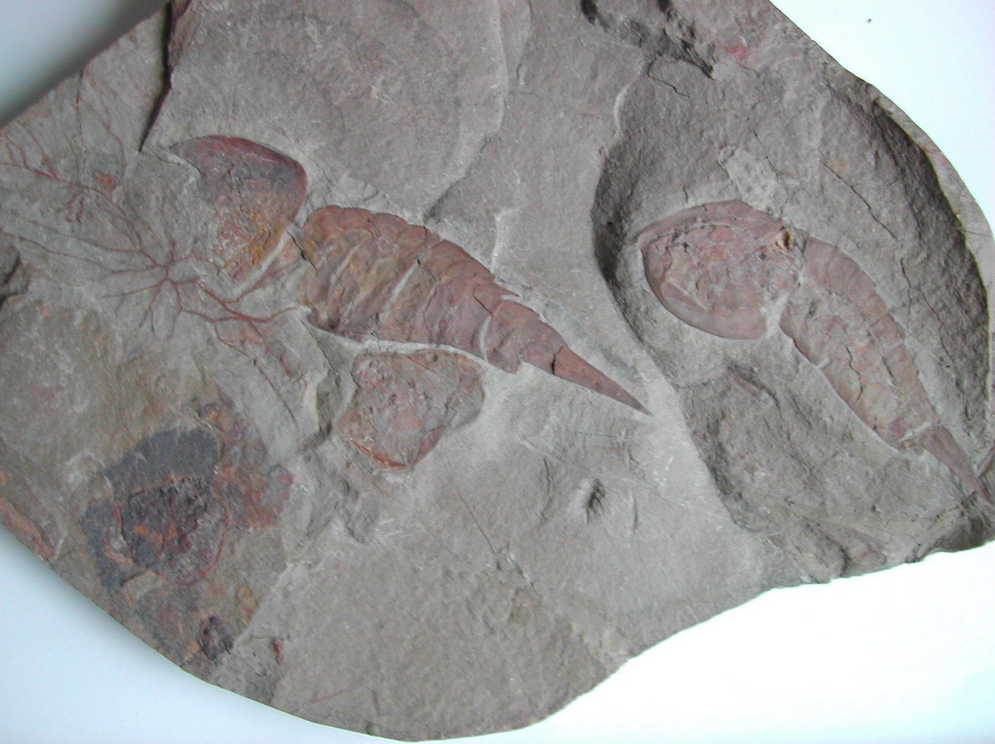

The Aglaspida, more correctly termed Aglaspidida, were a group of small, horseshoe crab-like arthropods that were once regarded as basal or ancestral horseshoe crabs. However they cannot be accommodated within the chelicerates. Now, though, they are regarded as a distinct group, possibly being close to the trilobites.

Scale bar shows cm and mm.

On the plate there is also a colony of Clonograptus sp. one of the earliest graptolites. Graptolites are fossil colonial animals known chiefly from the Upper Cambrian through the Lower Carboniferous (Mississippian).

There is about 35% restauration on the plate. The plate has some cracks, but is stable.

These fossils have been available on the market only for a short period several years ago and are hard to get by now.

Leptaglaspis schmidti and Clonograptus sp.

Early Ordovician (Arenigian), about 485 million years old

Upper Fezouata Formation

Zagora, Draa Valley  
 Morocco

The slab measures 18x20 cm, thickness of the slab varies.